Лабораторная работа №4
Исследование мультиплексоров и демультиплексоров

Цель работы: освоение принципов построения мультиплексоров и демультиплексоров.

Демультиплексор
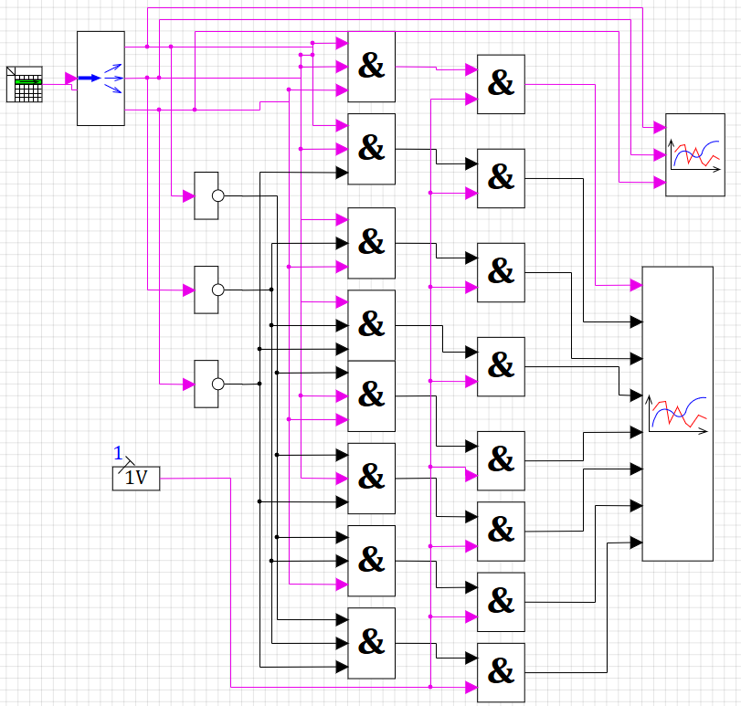

Входы |  |  | Выходы
A1 | A2 | A3 | Y7 | Y6 | Y5 | Y4 | Y3 | Y2 | Y1 | Y0
0 | 0 | 0 | 0 | 0 | 0 | 0 | 0 | 0 | 0 | 1
0 | 0 | 1 | 0 | 0 | 0 | 0 | 0 | 0 | 1 | 0
0 | 1 | 0 | 0 | 0 | 0 | 0 | 0 | 1 | 0 | 0
0 | 1 | 1 | 0 | 0 | 0 | 0 | 1 | 0 | 0 | 0
1 | 0 | 0 | 0 | 0 | 0 | 1 | 0 | 0 | 0 | 0
1 | 0 | 1 | 0 | 0 | 1 | 0 | 0 | 0 | 0 | 0
1 | 1 | 0 | 0 | 1 | 0 | 0 | 0 | 0 | 0 | 0
1 | 1 | 1 | 1 | 0 | 0 | 0 | 0 | 0 | 0 | 0
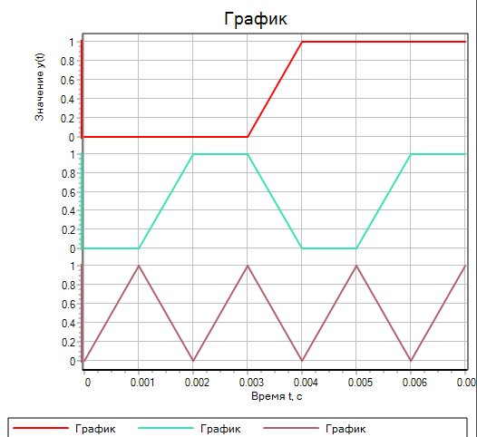

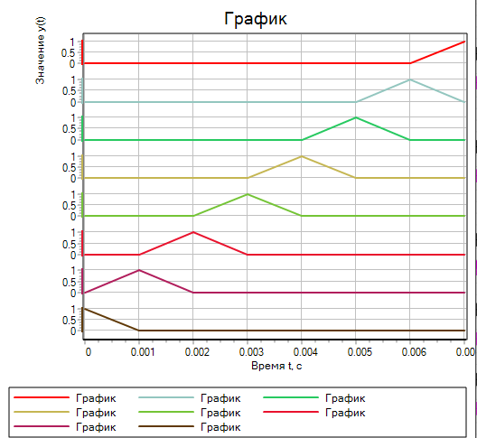

Мультиплексор
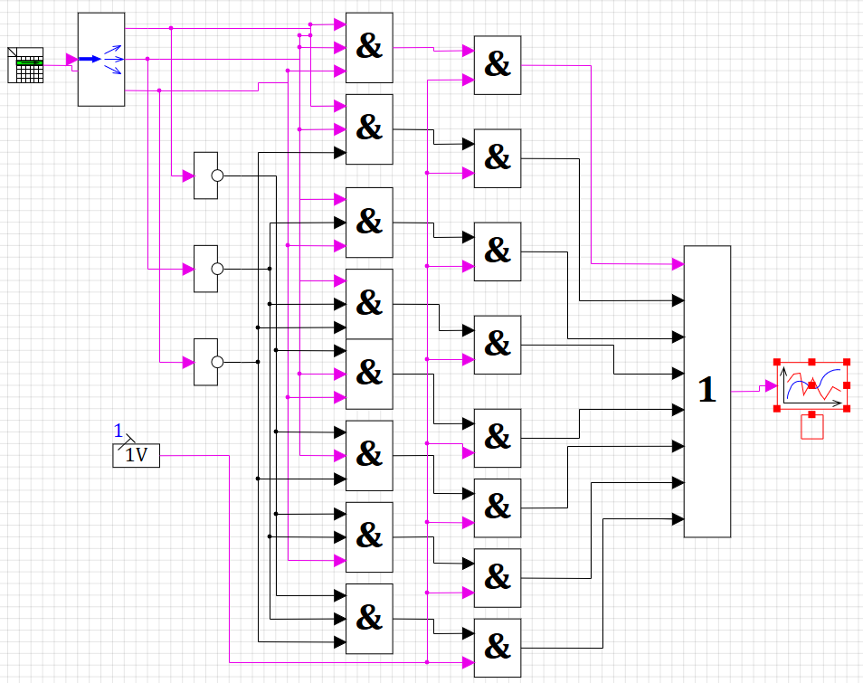
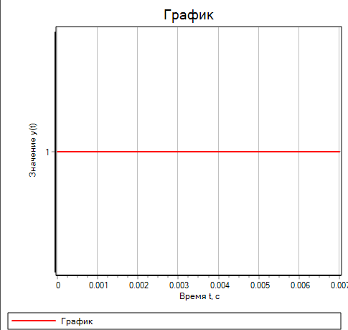

Выходы |  |  | Входы
Y1 | Y2 | Y3 | X7 | X6 | X5 | X4 | X3 | X2 | X1 | X0
0 | 0 | 0 | 0 | 0 | 0 | 0 | 0 | 0 | 0 | 1
0 | 0 | 1 | 0 | 0 | 0 | 0 | 0 | 0 | 1 | 0
0 | 1 | 0 | 0 | 0 | 0 | 0 | 0 | 1 | 0 | 0
0 | 1 | 1 | 0 | 0 | 0 | 0 | 1 | 0 | 0 | 0
1 | 0 | 0 | 0 | 0 | 0 | 1 | 0 | 0 | 0 | 0
1 | 0 | 1 | 0 | 0 | 1 | 0 | 0 | 0 | 0 | 0
1 | 1 | 0 | 0 | 1 | 0 | 0 | 0 | 0 | 0 | 0
1 | 1 | 1 | 1 | 0 | 0 | 0 | 0 | 0 | 0 | 0

